About ACG Join Donate Store Find a GI My ACG/Log In

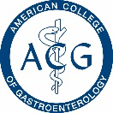

Membership Education Clinical Guidelines Publications Trainees Patients & Families

**Practice Management**

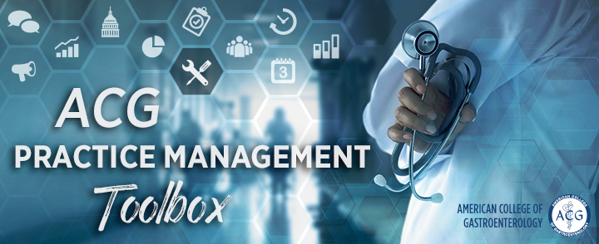

“Quote quote quote quote quote

quote quote quote quote quote”

Coding & Reimbursement

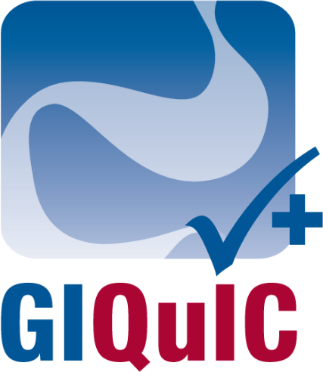

GIQuIC

**Quick link**

**Tri-society articles quick link**

**ICD-10 Playbook quick link**

**Coding Institute quick link**

FDA-Related Matters Committee News

Safety Alerts & Recalls

GI Moderate sedation

MACRA Tidbits

Making Sense of MACRA



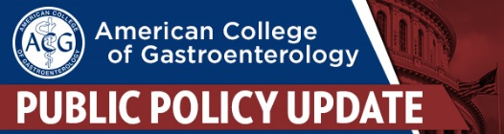

**This Week in   
Washington D.C.**

What’s happening on the hill?



Contact Us:

Name: 

Email:

Message: 